Todo -Project

Tech Stack:

MERN And MYSQL Stack Used in the Project:

Frontend: React.JS, Bootstrap, CSS3.

Backend: Node.JS, Express.JS, JWT.

Database: MongoDB and MySQL.

Install the Frameworks:

React:

* npx create-react-app Project_name
* install React Dependences Packages

Node.JS

* npm init
* install React Dependences Packages
* npm i express cors nodemon mysql mangoose

Database

* Create the database(todo)
* 2 Model Or Table used(user and task)
* User(userid,name,email,password)
* Task(task_id,task,userid(forging Key))

After complete the Project

Go to React Dir using npm build command and deploy

AIM

The TODO Project its note the task show it.then update and after done delete the task

Functionality

* First Planning the Project backend Process how to work draw the ER Model
* In their Project we used the React Framework so that three components
* Created its all functional, reused and well-structured and easily maintainable.
* Used the local Server Port:8000
* In the Project Done the CRUD Operation using Both Database it’s all Access with Restful Api Request.
* The JSW Token used to Authentication secure to the password saved in Hash key and also authorization used the React Hooks retrieve the data unique id and secured.

Client-side(file-structured)

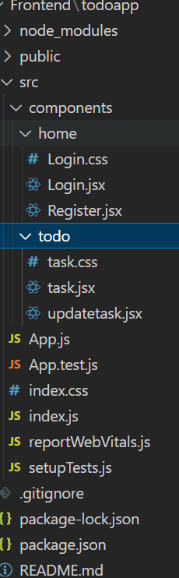

Server (file structured)

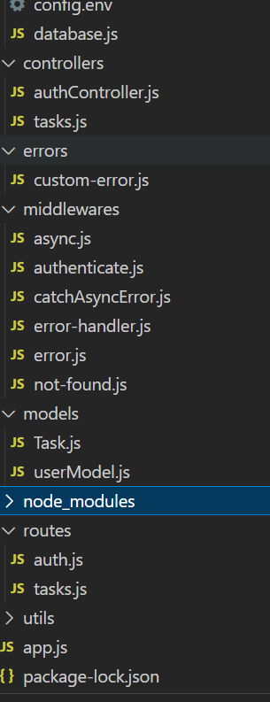

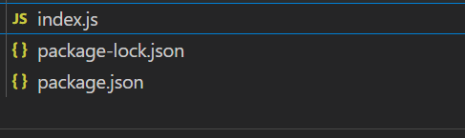

React Routes

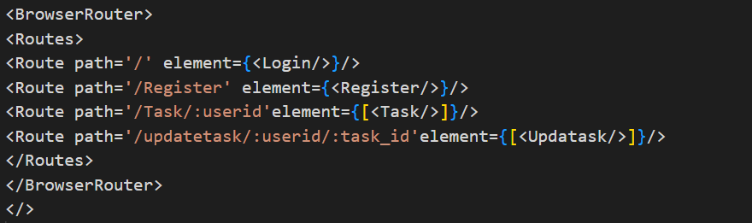

Test Restful API

Tech (POSTMAN)

All the Api Tested through first in their Postman Platform its are full function and Prefect Working After will used in the Frontend.

base_url= http://localhost:8000

**Login(authentication)**

{{base_url}}/api/v1/register

{{base_url}}/login

**Task(used in the backend Routes)**

{{base_url}}/api/v1/task/create(POST,GET)

{{base_url}}//api/v1/task/:_id(PUT,DELETE)

/deletetask

/updatetask/:task_id

/gettask/id/:task_id

/gettask/:userid

/inserttask/:userid'

Source Code : https://github.com/nandhu-techie-wizard/Todo